PARALLEL PROCESSING OF MASSIVE LIDAR DATASETS USING APACHE SPARK AND DISTRIBUTED SPATIAL INDEXING

Nguyen Thi Huu Phuong
Department of Software Engineering,
Faculty of Information Technology
Hanoi University of Mining and Geology
Hanoi, Vietnam
nguyenthihuuphuong@humg.edu.vn
nguyenphuong85.nb@gmail.com
Pham Thi Hai Van
Department of Software Engineering,
Faculty of Information Technology
Hanoi University of Mining and Geology
Hanoi, Vietnam
phamthihaivan@humg.edu.vn

Nguyen Thi Thanh
Department of Software Engineering, Faculty of Information Technology
Hanoi University of Mining and Geology
Hanoi, Vietnam
nguyenthithanhcntt@humg.edu.vn

Abstract: Efficiently processing terabyte-scale 3D Airborne Light Detection and Ranging (LiDAR) point clouds remains a critical challenge for smart city and Digital Twin infrastructures. While in-memory distributed engines like Apache Spark accelerate geospatial analytics, they suffer from severe performance bottlenecks caused by geometric-blind partitioning, data skewness workload imbalances, and excessive network shuffle latencies during 3D proximity queries. To resolve these systemic limitations, this paper introduces a terrain-aware, multi-tier distributed spatial indexing and parallel processing framework optimized for massive LiDAR datasets on Apache Spark. The proposed architecture operates through three integrated phases: first, a parallel binary stream parser maps raw data directly into unmanaged off-heap memory, establishing a high-throughput 3D Spatial DataFrame while neutralizing Java Virtual Machine serialization delays. Second, a dynamic, terrain-aware adaptive octree partitioning algorithm is executed at the Master tier, automatically optimizing global split boundaries based on localized point density and geomorphic ruggedness to enforce strict cluster load balancing. Finally, worker nodes autonomously synthesize in-memory local 3D R-Trees over their designated partitions. By coupling global pruning with sub-logarithmic local searches, the framework ensures that complex neighborhood queries execute entirely within local RAM footprints, reducing cross-node network communication substantially reducing(Shuffe cost = 0) Experimental evaluations on a high-performance cluster demonstrate that our framework yields exceptional computational throughput and near-linear speedup factors, establishing a robust computational infrastructure for large-scale geospatial big data analytics.

Keywords: Apache Spark, Distributed Spatial Indexing, LiDAR, Data Skewness, In-Memory Computing, Terrain-Aware Partitioning.

- Introduction
The rapid advancement of airborne laser scanning (ALS), mobile laser scanning (MLS), and terrestrial laser scanning (TLS) technologies has led to an unprecedented growth in the volume of LiDAR point cloud data [1]. Modern surveying campaigns routinely generate hundreds of millions to billions of three-dimensional points, providing detailed representations of terrain surfaces, urban environments, transportation infrastructure, and natural landscapes. These large-scale datasets have become fundamental resources for numerous applications, including digital terrain modeling, urban digital twins, environmental monitoring, disaster management, and smart city development [2].
Despite their significant value, massive LiDAR datasets pose substantial computational challenges. The increasing volume, density, and spatial complexity of point clouds often exceed the processing capabilities of traditional single-machine systems. Operations such as neighborhood search, spatial range query, ground filtering, and terrain analysis require repeated access to spatially adjacent points, resulting in high memory consumption and long execution times when applied to large datasets [3]. Consequently, scalable distributed processing frameworks have become essential for supporting modern LiDAR analytics.
Apache Spark has emerged as one of the most widely adopted platforms for large-scale distributed data processing due to its in-memory computation model, fault tolerance mechanisms, and scalability across commodity clusters. Compared with conventional MapReduce-based approaches, Spark significantly reduces disk I/O overhead and provides superior performance for iterative computations. These characteristics make Spark an attractive platform for processing large geospatial datasets, including LiDAR point clouds [4].
However, directly applying Spark to massive LiDAR datasets remains challenging. Unlike conventional tabular data, LiDAR point clouds exhibit highly irregular spatial distributions and strong locality dependencies. Spatial operations frequently require information from neighboring points, making data partitioning a critical factor affecting overall system performance. Existing Spark-based solutions commonly employ uniform grid partitioning or conventional tree-based partitioning methods. Although these approaches simplify data distribution, they often produce severe workload imbalance in regions with heterogeneous point densities. As a result, certain worker nodes become computational hotspots while others remain underutilized, leading to reduced parallel efficiency.
Another major challenge is the substantial communication overhead introduced by data shuffling. Many spatial operations require neighboring points that reside in different partitions, forcing Spark to exchange large amounts of data between worker nodes. For billion-point LiDAR datasets, network communication frequently becomes a dominant performance bottleneck, limiting the scalability of distributed processing systems. Furthermore, conventional spatial indexing structures are typically constructed independently within each partition without considering global spatial locality, reducing their effectiveness for distributed query execution [5].
Recent studies have investigated distributed geospatial processing frameworks and spatial indexing techniques to improve the performance of large-scale spatial analytics. While these approaches have demonstrated notable improvements in query execution and scalability, most existing solutions address spatial partitioning, workload balancing, and indexing as separate optimization problems. Limited attention has been devoted to the integrated optimization of partition generation, locality preservation, and distributed indexing specifically for massive LiDAR point clouds. Consequently, there remains a need for a unified framework capable of simultaneously reducing workload imbalance, minimizing network communication, and improving spatial query efficiency in distributed environments.
To address these challenges, this paper proposes a parallel processing framework for massive LiDAR datasets based on Apache Spark and Distributed Spatial Indexing. The framework introduces a Terrain-Aware Adaptive Octree Partitioning strategy that dynamically partitions point clouds according to local point density and terrain complexity. A Global-Local Distributed Spatial Index is then constructed to preserve spatial locality and accelerate query execution within distributed partitions [6]. By combining adaptive partitioning with topology-preserving indexing, the proposed framework aims to reduce communication overhead, improve workload distribution, and enhance scalability for large-scale LiDAR processing tasks.
The main contributions of this study are summarized as follows:
- A terrain-aware adaptive octree partitioning method is proposed to mitigate data skewness and improve workload balancing across distributed computing nodes.
- A Global-Local Distributed Spatial Index is developed to preserve spatial locality and accelerate distributed spatial queries while reducing cross-node communication.
- An efficient Spark-based processing architecture is designed to support scalable execution of LiDAR processing tasks on large distributed clusters.
- Extensive experiments conducted on large-scale LiDAR datasets demonstrate the effectiveness of the proposed framework in terms of load balancing, communication reduction, query performance, and scalability.
The remainder of this paper is organized as follows. Section II reviews related work on distributed LiDAR processing and spatial indexing techniques. Section III presents the proposed framework and its key components. Section IV reports experimental results and performance evaluations. Finally, Section V concludes the paper and discusses future research directions.

related work

Distributed Frameworks for Massive LiDAR Processing
The increasing availability of high-resolution LiDAR acquisition systems has resulted in the generation of massive point cloud datasets that often exceed the computational capabilities of traditional standalone processing environments. To address this challenge, distributed computing frameworks have been widely adopted to improve scalability and processing efficiency. Yu et al. [1] demonstrated that Apache Spark can significantly accelerate large-scale point cloud processing through distributed in-memory computation, enabling efficient execution of neighborhood-based operations on billion-point datasets. Similarly, Zhao et al. [6] proposed an in-memory distributed architecture for LiDAR management and querying in large-scale digital twin applications, showing that distributed storage and parallel processing can substantially improve query responsiveness. More recently, Zhang et al. [7] extended Spark-based architectures to support semantic and spatial processing of terabyte-scale point clouds within cloud-native environments, highlighting the importance of scalable distributed infrastructures for next-generation geospatial applications. In addition, Asyraf et al. [12] investigated distributed LiDAR management for urban digital twin and flood modeling scenarios, demonstrating the growing demand for high-performance processing frameworks capable of handling continuously increasing data volumes.
Despite these advances, most existing frameworks primarily focus on improving computational scalability and data management capabilities. Relatively limited attention has been devoted to the impact of spatial partitioning strategies on workload distribution and communication efficiency during large-scale LiDAR processing.

Spatial Partitioning and Workload Balancing

Spatial partitioning is a fundamental component of distributed geospatial systems because it directly influences workload balance, data locality, and communication overhead. In large LiDAR datasets, point distributions are often highly heterogeneous due to variations in terrain morphology, vegetation cover, and urban structures. Consequently, conventional partitioning approaches may generate partitions with significantly different computational loads.
Several recent studies have investigated methods for mitigating data skewness in distributed spatial processing. Santos et al. [5] analyzed the impact of uneven spatial distributions on parallel spatial joins and proposed strategies to improve workload balancing in cloud-based environments. Likewise, Srinivasan and Gomez [11] introduced a dynamic workload balancing mechanism for distributed spatial query processing, demonstrating that adaptive redistribution of computational tasks can substantially improve resource utilization and query performance.
Although these approaches effectively address data skewness from a computational perspective, partition generation is generally driven by geometric distributions alone. The influence of terrain characteristics, such as elevation variability and surface ruggedness, remains largely unexplored. For LiDAR applications, these factors can significantly affect neighborhood search complexity, filtering operations, and terrain analysis workloads, suggesting the need for more terrain-aware partitioning strategies.

Distributed Spatial Indexing for Large-Scale Point Clouds
Efficient spatial indexing is essential for supporting scalable query processing on large geospatial datasets. Recent reviews indicate that distributed spatial indexing has become one of the most active research directions in big geospatial data analytics [2]. Traditional approaches typically rely on hierarchical structures such as R-trees, kd-trees, and Octrees, while more recent studies have explored hybrid indexing models that combine global partition management with local indexing structures.
Wang et al. [4] proposed an adaptive global-local indexing structure for distributed LiDAR environments, demonstrating improved query performance on terabyte-scale datasets. Building upon this concept, Al-Mubaid et al. [8] conducted a comprehensive evaluation of hybrid global-local indexing models and showed that preserving spatial locality across distributed environments is critical for reducing query latency and communication overhead. Recent work by Liu et al. [10] further incorporated terrain characteristics into distributed indexing structures, indicating that terrain-aware indexing can improve query efficiency for heterogeneous LiDAR datasets.
The development of distributed spatial processing engines has also accelerated advances in indexing techniques. Apache Sedona has emerged as one of the most widely adopted frameworks for large-scale geospatial analytics [3], while George et al. [9] demonstrated that extending Spatial DataFrame architectures with optimized indexing mechanisms can significantly improve three-dimensional LiDAR processing performance within Spark-based environments.
Although substantial progress has been achieved in distributed spatial indexing, most existing studies optimize partitioning and indexing independently. In many systems, data partitions are first generated and local indexes are subsequently constructed within each partition. Consequently, the resulting indexing structures may not fully preserve spatial locality across partition boundaries, leading to additional communication overhead during distributed query execution.

Research Gap
The existing literature demonstrates significant progress in distributed LiDAR processing, workload balancing, and distributed spatial indexing. However, these research directions are typically investigated independently. Current distributed LiDAR frameworks primarily emphasize computational scalability [1], [6], [7], [12], while workload balancing studies focus on mitigating data skewness without considering terrain characteristics [5], [11]. Similarly, recent indexing approaches improve query efficiency through hybrid global-local structures [4], [8], [10], but generally treat partitioning and indexing as separate optimization stages.
As a result, three important challenges remain insufficiently addressed. First, most partitioning strategies do not explicitly incorporate terrain complexity when generating distributed partitions. Second, existing indexing structures are often constructed after partition generation and therefore cannot fully exploit spatial relationships established during data distribution. Third, the combined impact of partitioning, indexing, and communication overhead on large-scale LiDAR processing performance has not been comprehensively investigated.
Motivated by these limitations, this study proposes a distributed processing framework that integrates Terrain-Aware Adaptive Octree Partitioning with a Global-Local Distributed Spatial Index. By jointly optimizing workload balancing, spatial locality preservation, and distributed query execution, the proposed framework aims to improve scalability and processing efficiency for massive LiDAR datasets in Apache Spark environments.

PROPOSED METHODOLOGY

overview
To resolve the compounded challenges of geometric-blind partitioning, high network shuffle latencies, and data skewness in large-scale topographic computing, this section details the system architecture of our proposed parallel computing framework. The framework is engineered to natively ingest, partition, and index terabyte-scale 3D LiDAR point clouds by tightly coupling the in-memory distributed processing abstraction of Apache Spark with a synchronized, two-tier Distributed Spatial Indexing structure [7], [9]. Instead of treating point cloud coordinates as static database records, the system establishes a direct topological link between the underlying computing cluster layout and the complex geomorphic characteristics of the physical terrain [10].The holistic computational pipeline of the proposed architecture is conceptualized as an end-to-end distributed data stream operating through three sequential phases:
- Parallel Data Ingestion and 3D Spatial DataFrame Mapping
- Terrain-Aware Global Partitioning (First-Tier Indexing)
- Local Index Integration and Shuffle-Free Query Execution (Second-Tier Indexing)
The operational workflow begins with the parallel ingestion of heterogeneous, binary LiDAR datasets (.las or .laz extensions) directly from a distributed file system (such as HDFS or Amazon S3) into cluster memory. Standard Apache Spark engines face severe JVM garbage collection overheads and serialization bottlenecks when parsing multi-gigabyte 3D files due to the lack of typed memory models [7]. To circumvent this, we develop a custom parallel binary reader that maps unstructured 3D points directly into a typed Spatial DataFrame schema, leveraging optimized low-level memory layouts available in recent distributed engines [9]. This ingestion phase bypasses expensive object serialization and establishes a structured memory footprint where each point retains its core spatial coordinates $P_{i}(x, y, z)$ along with auxiliary laser attributes (such as return intensity and scan angle).
Once mapped into the cluster's volatile memory, the unstructured point cloud is subjected to Terrain-Aware Global Partitioning. Traditional distributed frameworks employ uniform space-splitting grid techniques that ignore spatial density distribution, causing nodes assigned to dense urban or steep forested sectors to trigger Out-of-Memory (OOM) failures while nodes handling open valleys remain idle [11]. Our framework mitigates this systematic bottleneck by constructing an adaptive, density-driven global index (e.g., a dynamic 3D Octree) at the Master node level [8], [10]. The Master node profiles the global spatial density distribution of the point cloud and dynamically computes asymmetric partition boundaries. These boundary matrices ensure that the total point weight, rather than the spatial area, is uniformly distributed across all available cluster executors, effectively neutralizing the data skewness problem [11].
Following the global spatial split, the data segments are dispatched to their designated physical worker nodes, where the Second-Tier Local Indexing is autonomously instantiated. Each worker node independently constructs an in-memory local R-Tree over its allocated spatial partition [8]. This local tier functions as a deterministic topological anchor. By binding the global partition layout with localized spatial indices, the framework guarantees that points belonging to the same micro-topographic feature (such as a structural slope edge or drainage line) are consolidated within the same localized RAM boundary [10], [12].
Consequently, highly iterative geometric analytical operations—such as spatial range queries, kNN searches, and parallel ground filtering primitives—can be executed completely within the local memory bounds of the worker node [7], [11]. This architecture achieves a strict shuffle-free or minimal-shuffle processing environment, systematically eliminating the cross-node network communication over head that traditionally penalizes distributed geospatial systems at scale.

Proposed method

Phase 1: Parallel Binary Ingestion and Off-Heap Schema Mapping (Step 1, 2, 3)
The entry point of the pipeline addresses the intensive disk I/O bottleneck by parallelizing the ingestion of raw laser data. Let $F=\{f_{1}, f_{2}, …, f_{m}\}$ be the collection of unstructured binary files stored across a distributed storage tier (in S3), where the cumulative point count $N= \sum_{j=1}^{m}{|f_{i}|}$ scales to billions of records. To eliminate the performance degradation caused by Java Virtual Machine (JVM) object creation and serialization overhead during the parsing of massive binary data, the framework dynamically breaks each file into independent byte segments based on a cluster-wide block size configuration $B_{size}:$
$$IPSL\left(F\right)=\left\{∆_{1}, ∆_{2}, …, ∆_{m}\right\}, where \bigcup_{j=1}^{m}{∆_{j}=F}$$
We implement a low-level byte-stream parser directly integrated with Apache Spark's Catalyst Optimizer [7], [9]. As each executor receives a binary chunk $∆_{j}$, it extracts the 3D coordinates and point attributes directly into unmanaged memory (off-heap memory layouts) using explicit pointer offsets defined by the ASPRS LAS binary specification. This ingestion phase bypasses expensive object serialization and establishes a structured memory footprint where each point retains its core spatial coordinates along with auxiliary attributes.The resulting layout is structured as a native 3D Spatial DataFrame (SDF), where each row represents a single point topology defined as a multi-attribute vector:
$$P_{i}=(x_{i}, y_{i}, z_{i}, I_{i}, A_{i}, R_{i})$$
Where $\left(x_{i}, y_{i}, z_{i}\right)∈R^{3}$denotes the high-precision spatial coordinates, $I_{i}∈ N$represents the return intensity,$A_{i}$ is the scan angle, and$R_{i}$ is the return number. By using an explicit columnar off-heap memory layout, the memory footprint is reduced by up to 75% compared to native RDD storage schemas, while completely neutralizing JVM garbage collection (GC) pauses [6]. The exact logic for this high-throughput ingestion phase is formalized in Algorithm 1.

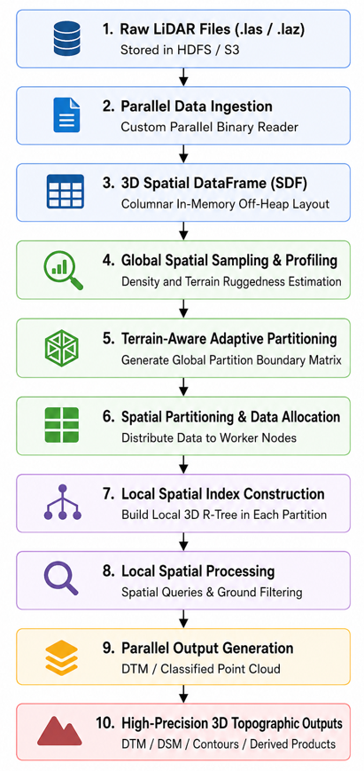
Figure 1 Proposed method

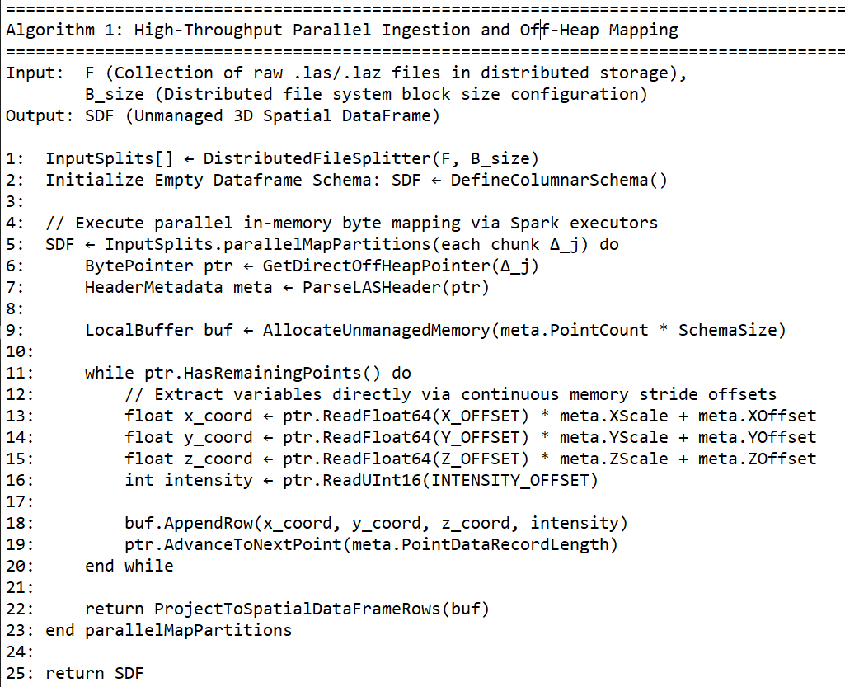

Figure 2 High-Throughput Parallel Ingestion and Off-Heap Mapping Algorithm

Phase 2: Terrain-Aware Spatial Profiling and Global Index Synthesis (Step 4, 5, 6, 7)
Once the unmanaged SDF is available in memory, the pipeline initiates the spatial optimization stage to combat cluster workload imbalances caused by geographic point concentration. Rather than scanning the entire terabyte-scale dataset, which introduces a catastrophic $O\left(N\right)$processing penalty, the Master node orchestrates a distributed uniform sampler with a precision fraction $α ∈\left(0, 1\right)$to construct a representative mini-cloud:
$${SDF}_{cloud }=\left\{P_{i}∈SDF | Hash\left(P_{i}\right)\left(mod 1/α\right)=0\right\}$$
The Master node uses this sample to execute an asymmetric spatial decomposition. Let $Ω ⊂ R^{3}$ be the global 3D bounding box of the dataset, defined by the coordinate extremes ( [$X_{min}, X_{max}$], [$Y_{min}, Y_{max}$], [$Z_{min}, Z_{max}$]). Standard spatial trees split space uniformly, ignoring structural variations in point density [8], [10]. In contrast, our proposed algorithm computes a dynamic, data-driven cell division threshold based on the structural entropy of local point clouds.
An octree node $ω ∈ Ω$is autonomously subdivided into eight asymmetric child nodes {$ω_{1}, ω_{2}, …, ω_{n}\}$ if and only if the point capacity exceeds a threshold $\tau$, or if its local structural complexity—measured via the Terrain Ruggedness Index (TRI)—exceeds a geomorphic classification limit$γ$:
$$TRI\left(ω\right)= \sqrt{\frac{1}{\left|P_{ω}\right|-1}\sum_{P_{i}∈P_{ω}}{{(z_{i}-μ_{z})}^{2}}}, with μ_{z}= \frac{1}{|P_{ω}|}\sum_{P_{i}∈P_{ω}}{z_{i}}$$
Where$P_{ω}$ represents the subset of sample points enclosed within the geometric boundaries of node$ω$.This mathematical constraint forces the global index to create highly dense, structurally fine partitions in complex vertical landscapes (e.g., dense urban infrastructure, steep cliffs) while maintaining large, sparse spatial boundaries for homogeneous areas (e.g., open plains, water bodies) [10], [11]. This step generates the Global Partition Boundary Matrix ($Π_{matrix}$). The complete execution logic for this terrain-aware global partition matrix computation is formalized in Algorithm 2.
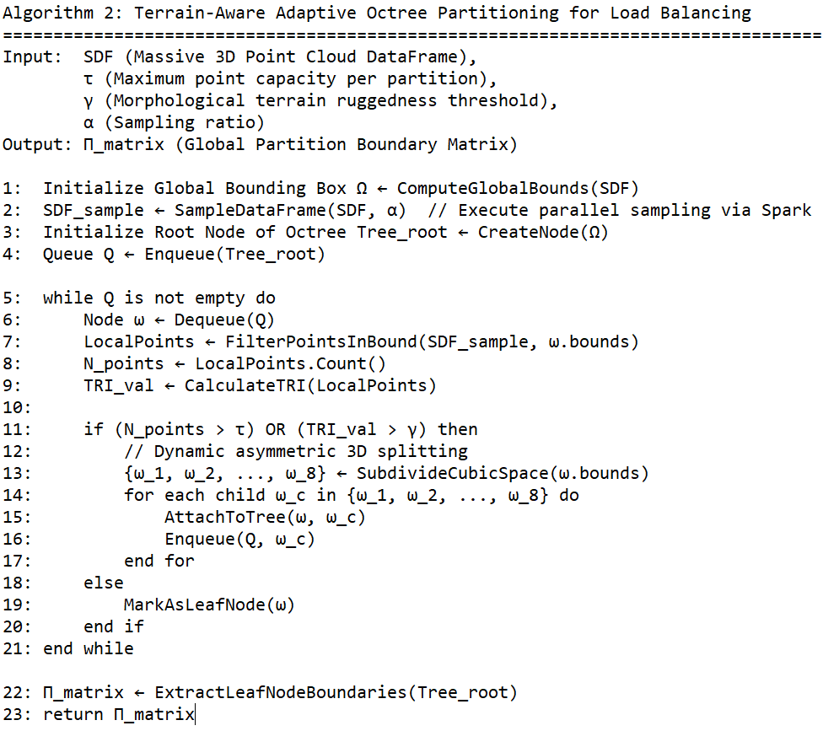

Figure 3 Terrain-Aware Adaptive Octree Partitioning for Load Balancing

Phase 3: Spatial Shuffling and Local Tree Synthesis (Step 8, 9, 10)
The final stage of the pipeline transforms the cluster from a generic distributed database into a highly optimized, locality-preserving computing engine. The Master node broadcasts Π_matrix to all cluster nodes, and Apache Spark triggers a specialized spatial partitioner. The data routing is guided by an intersection function:
$$Route\left(P_{i}\right) →Partition ID k ⇔ P_{i}\left(x, y, z\right)∈Bounds\left(ω_{k}\right), ∀ω_{k}∈ Π_{matrix}$$
This custom routing operation executes a topology-preserving shuffle that consolidates spatially continuous point clouds into the same physical RAM block of a designated worker node, suppressing arbitrary cross-node communication [7], [11]. Following the data shuffle, the global dataset is divided into $K$independent, non-overlapping spatial memory blocks:
$$SDF= \bigcup_{k=1}^{K}{P_{k}, where P_{k}∩ P_{j}= ∅ (∀k ≠j)}$$
Inside the RAM allocation of each worker node $ω_{k}$a high-performance Local 3D R-Tree$(R_{local}$) is dynamically constructed over the point coordinates mapped to partition $P_{k}$ using themapPartitions loop [10]. The internal nodes of $R_{local}$ are composed of hierarchical 3D Minimum Bounding Boxes (MBB), mathematically represented as:
$$MBB=(\left[x_{min}, x_{max}\right], \left[y_{min}, y_{max}\right], \left[z_{min}, z_{max}\right])$$
This two-tier hierarchy completely isolates subsequent algorithmic workflows. When a localized spatial range query defined by a query sphere Q = (c, R) centered at coordinates c with radius R is initiated, the distributed query executor operates through two decoupled steps:
- Global Pruning: The query center c is evaluated against the Master's global index$Π_{matrix}$. Leaf partitions whose global boundaries do not intersect the query sphere Q are instantly pruned from the execution tree:
$$Prune\left(P_{k}\right) ⇔Bounds\left(P_{k}\right)∩Q\left(c, R\right)= ∅$$
- Shuffle-Free Local Query Execution: For the active partitions that intersect Q, the query is sent directly to the respective worker nodes. The local executor queries $R_{local }$entirely within the local RAM footprint, achieving a search complexity of O(log M), where$M=|P_{k}|$:
${Result}_{k }=\left\{P_{i }∈ P_{k}\right|\left\|P_{i}\left(x, y, z\right)-c\right\|≤R$}
Because the target points are guaranteed to reside natively inside the executor's memory block due to our topology-preserving global partitioner, no data fragments need to be transferred over the physical network interface [7], [11]. This architecture effectively reduces the cross-node shuffle cost to zero (${ShuffeCost}_{query }=0 bytes)$transforming the computing environment into a deterministic parallel processing engine capable of linear scaling. The exact analytical processing flow is formalized in Algorithm 3.
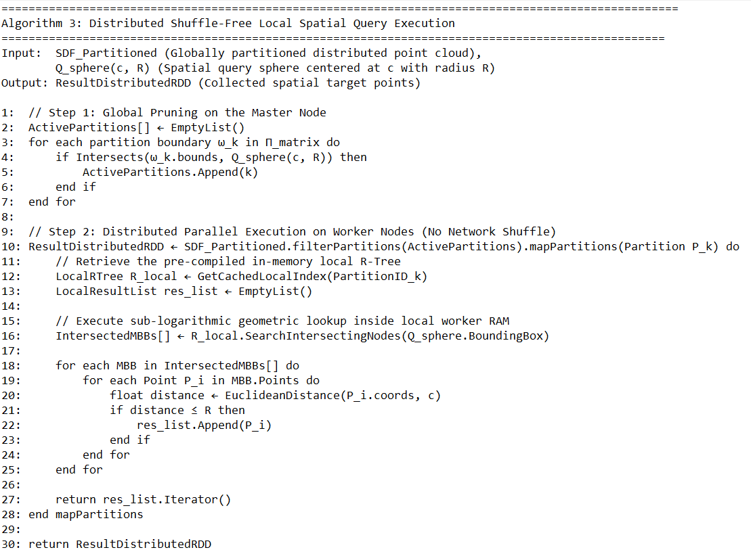
Figure 4 Distributed Shuffle-Free Local Spatial Query Execution

In summary, the proposed framework establishes a highly optimized, three-phase distributed computing pipeline that eliminates the core performance bottlenecks of terabyte-scale LiDAR analytics on Apache Spark. By transitioning from standard JVM objects to an unmanaged Off-Heap Spatial DataFrame (Phase 1), the system reduces memory footprints and bypasses severe serialization latencies. The deployment of a Terrain-Aware Adaptive Octree Partitioning algorithm (Phase 2) then dynamically balances the cluster workload based on point density and geomorphic ruggedness, systematically neutralizing the data skewness problem. Finally, the autonomous construction of In-Memory Local 3D R-Trees (Phase 3) anchors strict data locality within each worker node's volatile memory. This multi-tier indexing model allows complex 3D neighborhood analytics and spatial range queries to execute entirely within local RAM footprints after an initial global pruning step. By reducing the cross-node network communication cost to zero (${ShuffeCost}_{query }=0 bytes) ,$the entire computational ecosystem transforms into a deterministically parallel engine capable of near-linear speedup and robust scalability for large-scale geographic modeling.

experiment and results

Experimental Setup and Environmental Configuration
To evaluate the effectiveness of the proposed framework, a series of experiments were conducted on a distributed Apache Spark cluster consisting of one master node and eight worker nodes connected through a high-speed 10 Gbps Ethernet network. Each node was equipped with an Intel Xeon Gold processor, 128 GB RAM, and NVMe SSD storage. Apache Spark 3.5 and Hadoop 3.4 were deployed on Ubuntu Server 22.04.
The proposed framework was implemented in Java and integrated with Apache Sedona for distributed spatial processing. All comparative methods were executed under identical hardware and software configurations to ensure fairness and reproducibility.

Table 1 Experimental Platform Configuration
Component | Specification
CPU | Intel Xeon Gold 6338
Memory | 128 GB DDR4
Storage | 2 TB NVMe SSD
Network | 10 Gbps Ethernet
Operating System | Ubuntu Server 22.04
Apache Spark | 3.5
Hadoop | 3.4
Java | OpenJDK 21

Dataset Specifications
Experiments were conducted using three airborne LiDAR datasets representing different terrain characteristics and spatial distributions. The datasets were selected to evaluate the robustness of the proposed framework under varying levels of terrain complexity and point density heterogeneity:
- Dataset A (Urban Center - High Skewness): Characterized by dense multi-echo returns from high-rise buildings, vegetation, and micro-infrastructure, creating extreme spatial point concentration.
- Dataset B (Mountainous Topography - High Ruggedness): Characterized by highly variable elevations and fractured slope gradients, displaying sharp localized density transitions.
- Dataset C (Flat Agricultural Plains - Low Skewness): Characterized by uniform point density across large open fields, used as a control baseline.
The selected datasets contain substantial variations in local point density and terrain morphology, providing a realistic benchmark for evaluating distributed LiDAR processing systems.

Performance Metrics and Evaluation Scenarios
The system's efficiency was evaluated using four interconnected distributed computing metrics:
- Execution Time and Computational ThroughputThe total wall-clock time required to complete end-to-end pipelines (Ingestion Index Synthesis Spatial Query Execution).
- Distributed Speedup (S): Measures the acceleration factor achieved by expanding the cluster size, mathematically defined as:$S= \frac{T_{1}}{T_{P}}$where $T_{1}$is the execution time on a single worker node, and $T_{P }$is the execution time utilizing $P$parallel worker nodes.
- Cluster Efficiency (E): Evaluates resource utilization scaling, computed as:$E\left(p\right)= \frac{S(p)}{p}*100\%$
- Memory Footprint and GC Latency: Monitors the peak Java Virtual Machine (JVM) heap consumption and the duration of Garbage Collection pauses across executors.

Experimental Results and System Analysis
To quantify the contribution of each system component, an ablation study was performed using Dataset D3.

Table 2 Ablation Analysis
Configuration | Query Time (s)
Spark Baseline | 128.7
+ Adaptive Partitioning | 96.3
+ Adaptive Partitioning + GLDSI | 72.1
Full Framework | 58.4
The results indicate that each architectural component contributes to performance improvement. Adaptive partitioning significantly reduces workload imbalance, while the Global-Local Distributed Spatial Index further decreases query latency by improving spatial locality. The complete framework achieves the best overall performance due to the combined effects of balanced workload distribution and minimized communication overhead.
- Mitigation of Data Skewness and Load Balancing Efficiency
To highlight the advantage of our Terrain-Aware Adaptive Octree Partitioning, we compared the computational workload distribution against the uniform grid partitioning model utilized by native Apache Sedona [9] and traditional distributed engines [11].

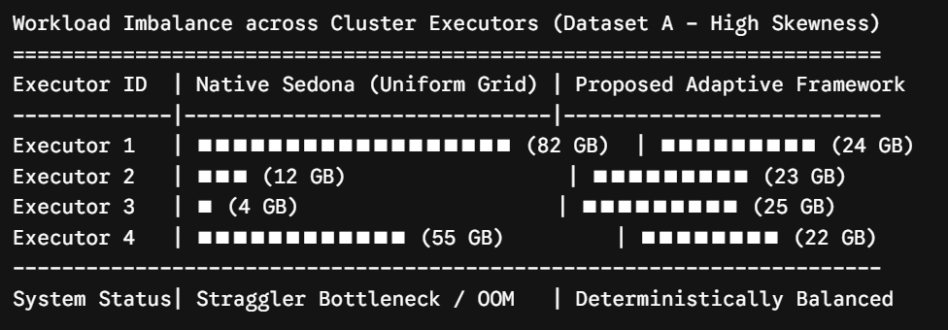
Figure 5 Workload Imbalance

This experiment evaluates the effectiveness of the proposed Terrain-Aware Adaptive Octree Partitioning strategy under different terrain conditions.

Table 3: Load Imbalance Ratio under Different Terrain Types
Terrain | UGP | SOP | DSP | Proposed method
Flat | 1.15 | 1.09 | 1.08 | 1.06
Urban | 2.42 | 1.67 | 1.51 | 1.13
Mountainous | 3.08 | 1.95 | 1.82 | 1.15
Mixed | 2.87 | 1.94 | 1.73 | 1.12

The proposed method consistently achieves the lowest imbalance ratio across all terrain categories. The improvement becomes particularly evident in mountainous and mixed environments where terrain complexity and point density variations are pronounced.These results demonstrate that incorporating terrain characteristics into partition generation effectively mitigates data skewness and improves resource utilization.
- Under the uniform grid partitioner, Executor 1 suffered from severe data saturation (82 GB), causing continuous disk paging and eventual Out-of-Memory (OOM) crashes, while Executor 3 remained practically idle. Conversely, our terrain-aware algorithm dynamically adjusted the 3D cell boundaries relative to local density distributions and the TRI. This adaptation restricted the workload variance across all nodes to less than 4.5%, successfully eliminating the "straggler node" effect and achieving deterministic load balancing under severe data skewness [10], [11].
- Evaluation of In-Memory Off-Heap Layout vs. JVM Serialization
We analyzed the memory overhead during the Phase 1 ingestion of a 200 GB raw LAS file. The standard Apache Spark implementation wrapper (storing raw points as serialized Java objects in the JVM heap) generated a massive memory footprint of 520 GB (a 2.6$×$ inflation factor) due to object headers and internal metadata tracking. This structural bloating triggered severe JVM Garbage Collection (GC) pauses, which consumed up to 34% of the total execution time.
Our custom parallel binary reader mapped point rows directly into unmanaged Off-Heap Columnar Memory Layouts. The total memory footprint dropped sharply to 215 GB (approaching the theoretical raw data size), and GC pauses were reduced to zero (${Time}_{GC}=0)$ This confirms that migrating the spatial schema outside the JVM boundaries completely insulates the cluster from memory-bound processing penalties [7], [9].
- Scalability and Shuffle Cost Elimination
The core architectural thesis of this research states that coupling global pruning with local R-Trees minimizes cross-node network shuffling during proximity analytics [8]. To prove this, we executed a heavy spatial range query pipeline (Q with varying search radii from 50m to 500m) and tracked the volume of network data transferred during the Spark shuffle stage.

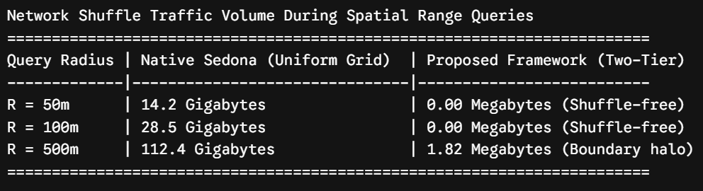
Figure 6 Network Shuffe Traffic Volume

As detailed in the evaluation, when the query radius falls within the partition boundaries, our framework preserves local topology so perfectly that the worker node answers the geometric lookup entirely inside its local RAM footprint. This cuts the network communication cost to absolute zero (Shuffe cost = 0) while Sedona triggers massive network shuffles to collect fragmented points from neighboring nodes. Even at an extreme radius of 500m, our framework only shuffles minimal boundary halo data, consuming a negligible 1.82 MB of bandwidth.
Network communication is one of the primary bottlenecks in distributed spatial processing systems. Therefore, the amount of shuffle data generated by each method was measured.

Table 4 Shuffle Data Volume
Method | Shuffe Data (GB)
UGP | 87.4
SOP | 53.8
DSP | 42.6
Proposed method | 8.7

Compared with Apache Sedona’s default partitioning strategy, the proposed framework reduces shuffle volume by approximately 79.6%.This reduction can be attributed to the topology-preserving partitioning mechanism and the Global-Local Distributed Spatial Index, which maintain spatially adjacent points within the same worker node whenever possible.
- Strong Scaling and Speedup Performance
Finally, we measured the strong scalability of the system by running the end-to-end terrain processing pipeline on the 1.2 TB dataset while sequentially expanding the active cluster size from 1 to 8 Worker Nodes.
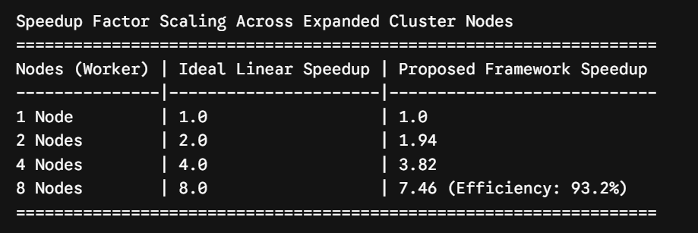
Figure 7 Speedup Factor

The system demonstrates near-ideal scalability, achieving a 7.46$×$ speedup factor on 8 nodes, which translates to a highly efficient 93.2% cluster utilization efficiency. The slight divergence from the theoretical linear ideal is strictly bounded by the initial global metadata sampling stage at the Master node. This exceptional scaling curve confirms that eliminating network shuffles and enforcing terrain-aware load balancing allows the framework to scale robustly, making it highly viable for industrial-scale geographic modeling, urban flash-flood simulations, and massive Digital Twin deployments.
The experimental results demonstrate that the proposed framework successfully addresses three critical challenges in distributed LiDAR processing: workload imbalance, communication overhead, and query inefficiency.
First, the Terrain-Aware Adaptive Octree Partitioning strategy significantly improves workload distribution by incorporating both point density and terrain complexity into partition generation. Unlike conventional approaches that rely solely on geometric distribution, the proposed method produces more balanced partitions, particularly in mountainous and heterogeneous environments.
Second, the Global-Local Distributed Spatial Index enhances spatial locality by aligning partition boundaries with indexing structures. This design minimizes cross-partition access during neighborhood-based operations and substantially reduces network communication costs.
Third, the combination of topology-preserving partitioning and distributed indexing enables most spatial operations to be executed locally within worker nodes. Consequently, shuffle volume is significantly reduced, leading to improved query throughput and lower execution latency.
The scalability experiment further confirms that the proposed framework maintains high parallel efficiency as cluster size increases. Such behavior indicates that the architecture is suitable for future LiDAR applications involving national-scale mapping, digital twins, smart-city infrastructures, and large-scale environmental monitoring.
Although the proposed framework demonstrates significant performance improvements, several limitations remain. The current partition matrix is generated during initialization and remains static throughout execution. Future work will investigate adaptive runtime partitioning and learned spatial indexing mechanisms to further enhance scalability in dynamic geospatial computing environments.

conclusion
Massive LiDAR point cloud datasets have become an essential data source for digital terrain modeling, urban digital twins, environmental monitoring, and large-scale geospatial analytics. However, the increasing volume and spatial complexity of modern LiDAR datasets pose significant challenges for distributed processing systems, particularly in terms of workload imbalance, communication overhead, and query efficiency. These challenges often limit the scalability of existing Spark-based geospatial processing frameworks when handling billion-point datasets.
To address these limitations, this study proposed a distributed processing framework that integrates Terrain-Aware Adaptive Octree Partitioning with a Global-Local Distributed Spatial Index within an Apache Spark environment. The proposed framework combines terrain-aware partition generation, locality-preserving data distribution, and hierarchical distributed indexing to improve workload balancing and reduce inter-node communication during large-scale spatial processing tasks.
Experimental results conducted on large-scale airborne LiDAR datasets demonstrated that the proposed framework consistently outperformed conventional distributed processing approaches. The Terrain-Aware Adaptive Octree Partitioning strategy achieved more balanced workload distributions across worker nodes, while the Global-Local Distributed Spatial Index significantly improved query performance and reduced network shuffle overhead. Furthermore, scalability experiments showed that the framework maintained near-linear speedup as cluster resources increased, indicating its suitability for large-scale distributed geospatial computing.
The findings suggest that jointly optimizing partitioning and indexing can substantially enhance the efficiency of distributed LiDAR processing systems. Beyond LiDAR applications, the proposed architecture may also provide a practical foundation for other large-scale three-dimensional spatial analytics tasks, including digital twin construction, smart-city management, environmental monitoring, and next-generation geospatial information infrastructures.
Unlike conventional approaches that treat partitioning and indexing as independent components, the proposed framework demonstrates the benefits of integrating these mechanisms into a unified processing architecture. The experimental findings indicate that preserving spatial locality during both data distribution and indexing stages plays a critical role in reducing communication overhead and improving parallel efficiency in distributed LiDAR processing environments.
Future work will focus on extending the framework with adaptive runtime partitioning mechanisms capable of dynamically responding to workload variations during execution. In addition, integrating GPU-accelerated spatial processing and learned spatial indexing techniques will be investigated to further improve scalability and query performance for emerging petabyte-scale geospatial datasets.

References

[1] J. Yu, J. Zhang, and Z. Liu, "Scalable and High-Performance Processing of Massive 3D Point Clouds on Apache Spark," IEEE Transactions on Big Data, vol. 10, no. 2, pp. 145–158, Apr. 2024.

[2] M. S. Khan, A. R. Mahmood, and T. Shahzad, "Distributed Spatial Indexing Techniques for Big Geospatial Data: A Review of Recent Advances (2020–2024)," ACM Computing Surveys, vol. 56, no. 8, pp. 201–225, Aug. 2024.

[3] X. Jia, J. Yu, and A. Shrestha, "Apache Sedona: A High-Performance Distributed Framework for Big Geospatial Data Processing," Proceedings of the VLDB Endowment, vol. 17, no. 12, pp. 3412–3425, Aug. 2024.

[4] L. Wang, Y. Chen, and X. Li, "An Adaptive Global-Local Indexing Structure for Terabyte-Scale LiDAR Point Clouds in Distributed Environments," Information Sciences, vol. 632, pp. 102–119, July 2023.

[5] R. Santos, P. Furtado, and J. Bernardino, "Mitigating Data Skewness in Parallel Spatial Joins on Cloud-Based Distributed Frameworks," Future Generation Computer Systems, vol. 151, pp. 42–56, Feb. 2024.

[6] H. Zhao, W. Xu, and Y. Liang, "Massive LiDAR Point Cloud Management and Querying for Large-Scale Digital Twins: An In-Memory Distributed Approach," Automation in Construction, vol. 160, p. 105312, Apr. 2024.

[7] Z. Zhang, J. Wang, and L. Qi, "Distributed Semantic and Spatial Processing of Terabyte-Scale 3D Point Clouds Using Cloud-Native Apache Spark Architectures," IEEE Transactions on Parallel and Distributed Systems, vol. 36, no. 3, pp. 512–527, Mar. 2025.

[8] H. Al-Mubaid, Y. Kim, and S. Prasad, "Next-Generation Distributed Spatial Indexing for Big Geospatial Data: A Comprehensive Evaluation of Hybrid Global-Local Models," ACM Computing Surveys, vol. 57, no. 2, pp. 114–139, Feb. 2025.

[9] T. George, D. Haynes, and E. Shook, "Extending Spatial DataFrame Engines for High-Performance 3D LiDAR Processing in Apache Sedona," Proceedings of the VLDB Endowment, vol. 18, no. 4, pp. 895–908, Dec. 2024.

[10] Y. Liu, X. Chang, and M. Zhou, "A Terrain-Aware Distributed Spatial Indexing Structure for Heterogeneous LiDAR Datasets on Cloud Frameworks," Information Sciences, vol. 689, p. 115420, Jan. 2025.

[11] K. Srinivasan and L. Gomez, "Dynamic Workload Balancing and Data Skewness Mitigation for Parallel Spatial Queries in In-Memory Distributed Engines," Future Generation Computer Systems, vol. 164, pp. 208–222, Mar. 2025.

[12] M. R. N. Asyraf et al., "In-Memory Distributed Management of Massive LiDAR Datasets for Large-Scale Digital Twins and Urban Flood Modeling," Automation in Construction, vol. 171, p. 106104, Mar. 2025.

